## H2 DB data

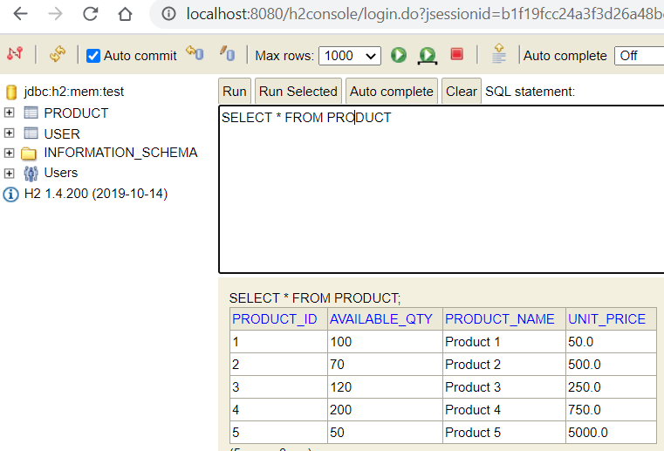

## Invoke service prior to login to ensure token validation is done

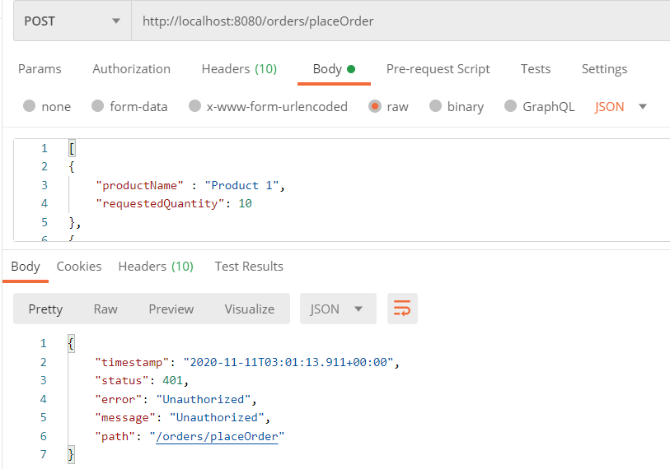

## Login Service – returning token

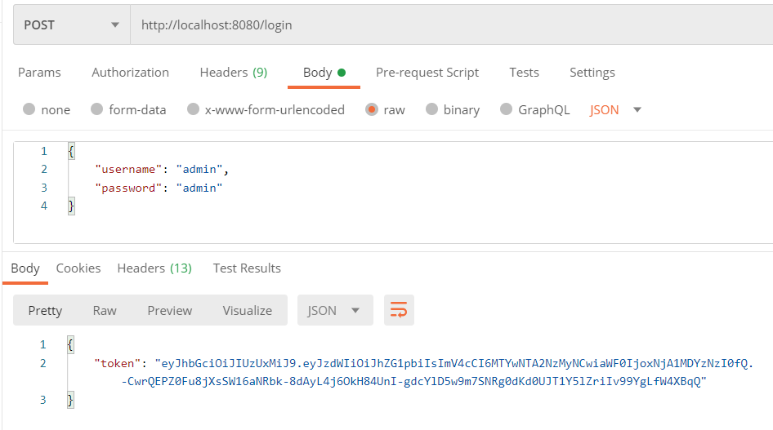

## Supply token, request products listing

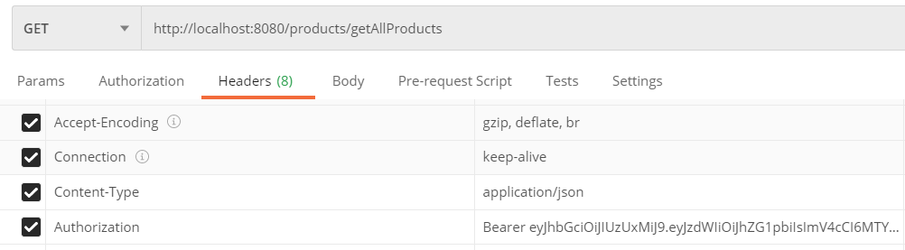

<http://localhost:8080/products/getAllProducts>

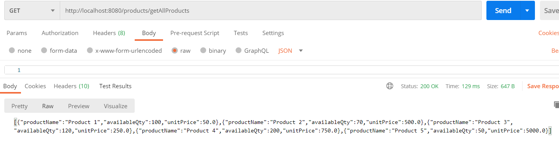

## Place Order

### Validation tests

#### Without token

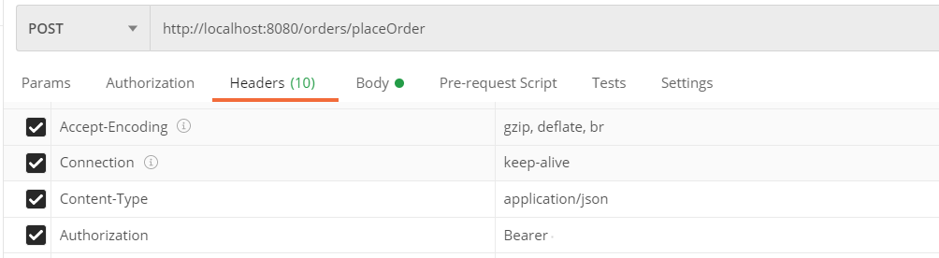

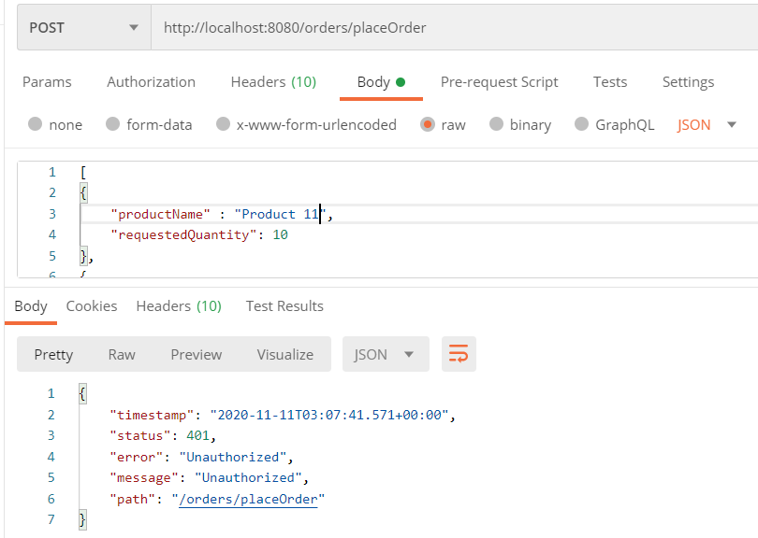

#### With incorrect product name

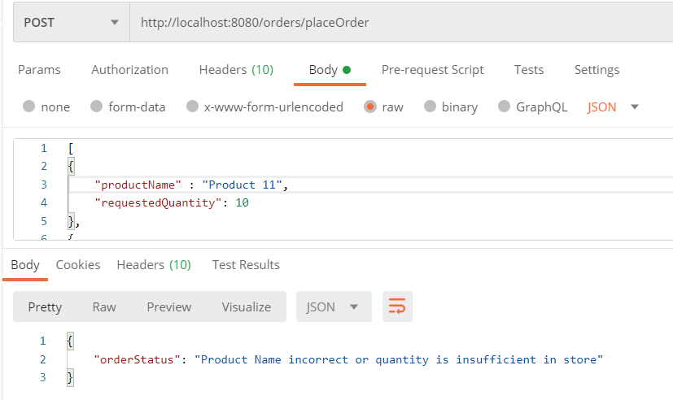

#### Requested Quantity is large

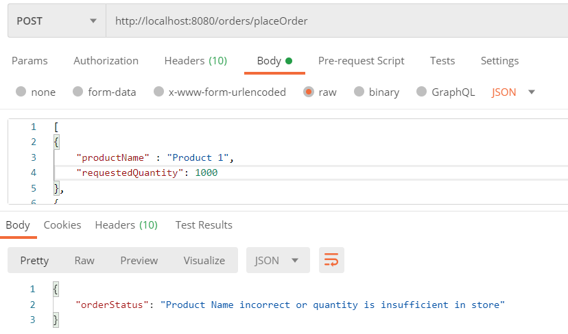

### Success scenario

